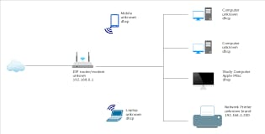

This is a home network topology diagram showing how various devices connect to the internet via a router. Here's a breakdown of each component:

1. Internet (Cloud symbol)

Represents the external internet connection from the ISP (Internet Service Provider).

2. ISP Modem/Wireless Router (192.168.3.1)

Central device connecting the home to the internet.

Has both wired and wireless connections.

3. Connected Devices

Wireless Devices (Wi-Fi Drop)

Mobile: Connects wirelessly to the router.

Laptop: Also connects via Wi-Fi.

Wired Devices (Ethernet Drop)

Computer (unknown type): Two such devices are connected via wired Ethernet.

Study Computer (Apple iMac): Connected by Ethernet.

Network Printer:

Brand unknown.

Also connected via Ethernet.